List of Tables

Table 1 This table/figure caption sometimes can get too long with subitems (a) something else here (b) The next item here (c) This too? 2

Table 1 This table/figure caption sometimes can get too long with subitems (a) something else here (b) The next item here (c) This too?

|  |  |
| --- | --- |
| Heading | Table 1 |
|  |  |

The table caption is shortened in table of content.

How to do it?

1. Display the returns by pressing  button
2. Go to an empty section of the word document (Preferably a new one / last page) and press “Ctrl + Alt + Enter”. You will see the “Hard Return”. The difference is that there will be a small box around the hard return and no box around soft return 
3. Copy this hard return character and paste it into the table caption. 
4. Sometimes this copy changes the format, so paste the “table-caption” format if it changes.



Use this button . First place the cursor on the format you want, Press the “Format Painter” button, then click on where you want to apply this formatting



1. Update the List of Tables > Update the entire table.

Before

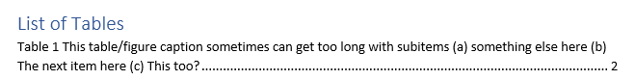

After

